# Acceptance Criteria Testing

## Story ID 9

User story: As a customer I want to be able to track my incoming packages so that I can see the status of deliveries and know which day packages should be delivered.

* I want to be able to enter a tracking number and find out the status of the package.
* I am able to view the history of the package.

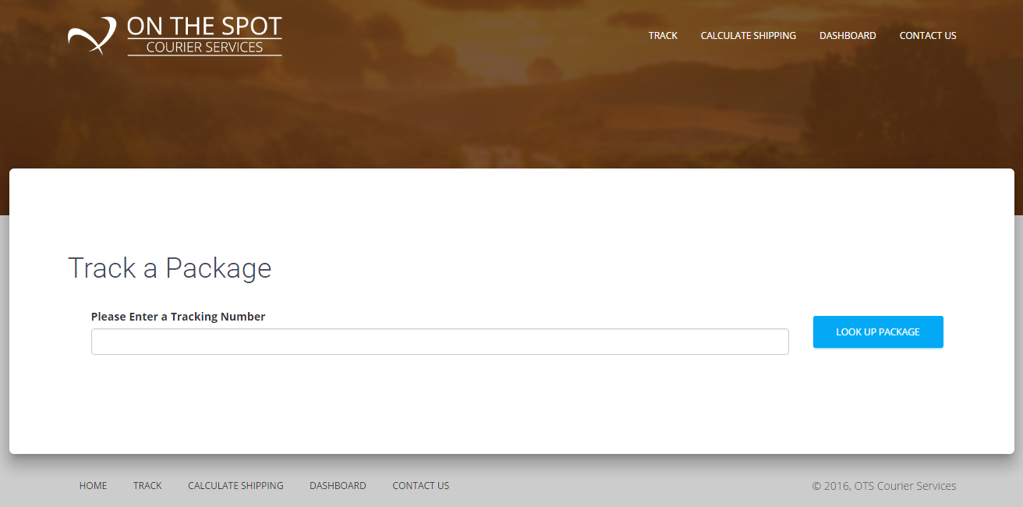

In the “Please Enter a Tracking Number” field, the costumer or sender will be able to search for the location of their package. Either if they are waiting for it, or sending it to someone. The information of the driver, location and estimated time of delivery will then show on the screen.